EXERCISE 1:

A database is to be made to store information about a catalogue of CDs. Information to be
stored about each CD includes their title, price, genre, and a list of tracks. Each CD will also
have an artist, and each artist may produce several CDs. Tracks will have a title and a
running time (in seconds). Artists have names associated with them and it should be
possible to search the database by artist names.

EXERCISE 2:
I want to represent a property listing service where you can book a property in advance, searchable by accommodation type, facilities, entertainments available, and show pricing for it.

EXERCISE 3:

Based on your personal hobbies make a database to track your collection of books or music, sports or games ,or track the movies that you've watched. Get a basic version working then build over it to go deeper. For example if you tracking movies then start from a point where your daily use cases are satisfied and build on it to include features from popular websites and so on. This can be the basis of your personal project. Keep a futuristic, well thought out plan. Your database design should be done in a way that each phase can be expanded to add more features without breaking previous design or having to do data migrations.

EXERCISE 4:

A horticultural research company is conducting a study of different plants grown using a new fertilizer. You are responsible for designing the database. You need to store data on a variety of plants including scientific name, common name and family. The environmental conditions of each greenhouse should be recorded including temperature and luminosity. The soil substrate (type and PH) and the dilution of the new fertilizer is recorded for each tray. A conclusion for each tray result should be recorded. Daily observations of plant growth for each plant group
must be stored with an optional comment. Identify the data, and then model the entities in an ERD.

Keep in mind you are expected to do some domain research and
identify good use cases and data needs beyond basics.

EXERCISE 5:
Design a database schema for the following.
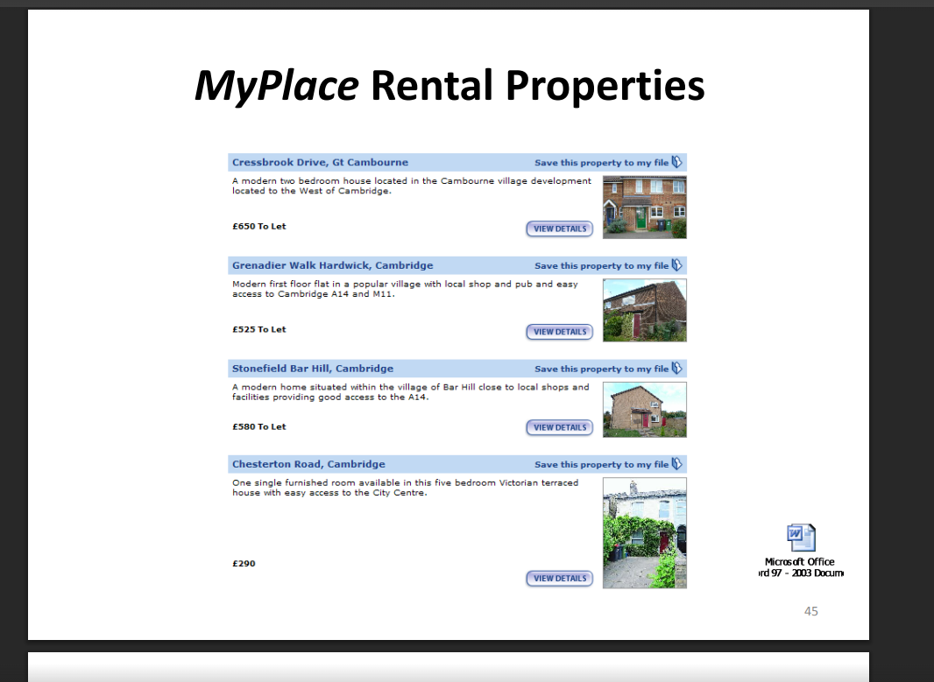

EXERCISE 6:
This dashboard represents a comprehensive, full-stack workflow application designed to solve a multi-faceted problem faced by modern community maker spaces, tool libraries, and repair initiatives. Below is an overview of the core problem this UI addresses, followed by a detailed explanation of each feature and how they work together as a synchronized system.

1. The Core Problem Statement
Community tool libraries and "Repair Cafés" play a vital role in the circular economy by reducing electronic waste, saving money, and teaching repair skills. However, managing these operations manually is highly complex:
Tool Safety & Calibration Tracking: Shared power tools wear out and become dangerous. Keeping track of which tools are calibrated, overdue for safety inspection, or retired is crucial for liability and safety compliance.
Intake & Repair Chaos: When community members bring in broken items, organizers struggle to diagnose symptoms, assign them to volunteers with the right specialties, and track the item's progress.
Component Supply Shortages: Repairs require spare parts (screws, fuses, capacitors). If parts run out, repairs stall. If parts aren't tracked, inventory disappears.
Impact Quantifying: It is difficult to measure the environmental impact (such as landfill waste diverted in kilograms or carbon emissions avoided) to justify funding or share success with the community.
This UI consolidates these disconnected operations into a single, cohesive Community Tool & Repair Hub designed in a warm, nature-inspired Organic Natural Tones Theme (cream, sand, soft greens, and warm terracotta accents).

2. Feature-by-Feature Explanation
🌿 Real-Time Environmental Metrics (Stats Banner)
Located at the very top, this module calculates the cumulative impact of the hub in real-time:
Carbon Offset: Calculates greenhouse gas emissions avoided by repairing items instead of manufacturing new ones. Each repair category (e.g., Electronics vs. Textiles) uses a scientific multiplier based on the item's weight.
Waste Diverted: Accumulates the exact physical weight of all items successfully repaired and kept out of landfills.
Fixes Completed / Active Loans / Active Fixers: Tracks active workshop throughput, borrower statistics, and volunteer on-shift capacity.
Parts Warnings: Displays a dynamic count of low-stock micro-parts. If a part falls below its minimum threshold, this card turns terracotta and pulses to warn staff.
📝 Check-In & Diagnostics Station
This forms the entry point for incoming community repairs:
Member & Item Intake: Staff enter the owner's details, the broken item's name, category, and physical weight.
Real-time Carbon Estimator: As soon as the weight and category are selected, a live sidebar preview displays the estimated carbon savings if the repair succeeds.
Skills-Matched Volunteer Filtering: The dropdown menu automatically analyzes the item's category and ranks active volunteer fixers who specialize in that category (e.g., electronics, woodworking) at the very top with visual stars (✨), simplifying delegation.
🔧 Locker Shelf Grid Map & Asset Calibration
A physical representation of the workshop's shared inventory:
Shelving Grid Map: Visually represents tool storage zones. Staff can instantly see which tools are Available (green), Checked Out (sand), In Repair (terracotta), or Retired (muted gray).
Calibration Compliance Monitor: Selecting any tool opens its calibration ledger. It tracks the last inspection date against the tool's required safety interval and dynamically warns staff if a tool's safety certification is Overdue.
Safety Logbook: Technicians can run safety checks, input detailed measurement notes, and submit a Pass/Fail certification. Fails automatically lock the tool into the "In Repair" state, preventing unsafe tool checkout.
📋 Repair Kanban Board
This tracks the operational lifecycle of repair tickets across five sequential column stages:
Intake Queue: Newly logged items awaiting diagnostic inspection.
Diagnosing: Active inspection of symptoms.
In Progress: Repair work underway.
Awaiting Parts: On hold if specific components are required.
Completed: Successfully fixed items, triggering carbon and weight accrual.
Staff can advance cards through the workflow or send them back to earlier stages with responsive column navigators.
📦 Inventory & Deduction Bridge
A specialized stock management system that coordinates with the active repairs:
Micro-Parts Drawers: Tracks stock counts and physical drawer locations for key components like fuses, resistors, gear sets, and sewing threads.
Automated Deduction on Close: When a ticket is moved to "Completed," a drawer overlay intercepts the action. Staff select the exact number of parts consumed. Upon closing, the system automatically deducts those units from the master inventory list.
Stock Alert Synchronization: If inventory falls below the safety stock threshold, a row warning activates, immediately incrementing the global Parts Warning alert in the header stats banner.
Audit Bridge Log: Generates a ledger showing recent transaction details (which ticket consumed which parts) to ensure strict accountability.
https://ai.studio/apps/62734bb7-7d8d-4b17-ac16-c3a3ade0c09a

EXERCISE 7:

In a physical escape room venue, running operations smoothly is highly demanding and prone to chaos. A single Game Master (GM) is responsible for simultaneously managing multiple active groups of players, maintaining strict safety protocols, sending clues at appropriate times, and keeping fragile IoT props running.
Without a unified cockpit, Game Masters are forced to juggle walkie-talkies, separate terminal commands, and handwritten timers. This leads to operational friction, delayed hints, and potential safety hazards.
The Escape Room Control Center Dashboard solves these issues by acting as a single, centralized mission control interface. It merges real-time room timers, synchronized clue dispatchers, hardware health monitors, and a direct visual feed into a single high-contrast console.

Visual and Functional Feature Breakdown
The application is styled with an immersive Slate Dark Theme featuring high-contrast neon green, amber, sky-blue, and red indicators that mirror a genuine security bunker.

1. Zone 1: The Master Grid (Multi-Room Overview)
This birds-eye view provides a global overview of the entire facility, structured as high-density physical cards representing individual rooms:
Status-Driven Visuals: Card borders and status tags shift dynamically based on state (READY is Slate Gray, ACTIVE is Emerald Green, MAINTENANCE is Amber Yellow).
Low-Time Warning: Under 5:00 minutes, the timer begins flashing amber to alert the GM of a critical bottleneck.
Safety Lockouts (Emergency Stop): A prominent, global Red Emergency Button instantly simulates unlocking all electromagnetic maglocks across all physical chambers, pausing all active room timers and broadcasting a vocal safety announcement.
Quick Timer Controls: Game Masters can quickly pause, resume, or add/subtract time in 60-second increments directly from the room's summary card without opening full console screens.

2. Zone 2: Room Deep-Dive & Clue Console
Clicking any room card focus-locks that room, loading a specialized workspace designed to handle player interactions in real-time:
Interactive Puzzle Pipeline: A linear progress bar tracks what stage the players are on (e.g., Padlock [Solved] ➔ Laser Grid [Active] ➔ Bookshelf Magnet [Locked]). GMs can click nodes to manually trigger overrides or set specific step active levels.
Clue Tracker: Displays clues used out of available limits (e.g., 2 / 3 Used). GMs can override the clue counter using simple increment/decrement buttons.
Preset Clue Library: A searchable catalog of preset clues, automatically filtered by the currently active puzzle. GMs can select a preset clue to auto-populate the composer.
Live Clue Composer: GMs can edit preset hints or write custom messages. Clicking Send Clue to Screen pushes the text to the simulated monitor, accompanied by a dynamic Text-to-Speech Intercom Voiceover that reads the hint aloud.
Force Override Bypass: A manual control allows GMs to mark the active puzzle as solved from the desk, automatically activating the next puzzle sequence in line.

3. Zone 3: Live Player Screen Monitor
This section visualizes exactly what the players see on the actual physical TV monitor mounted inside the room:
Simulated CRT Display: Rendered with analog-inspired scanlines, flickering effects, and responsive lighting based on room themes (e.g., gold lighting for Pharaoh's Tomb, deep neon magenta for Cyberpunk Heist).
Typewriter Dispatch Effect: When a hint is dispatched from mission control, it types itself out character-by-character on the player's monitor in real time.
Simulator Control Matrix: For administrative testing, GMs can use the simulation buttons to pretend players physically solved the room puzzle or to trigger simulated hardware faults on the spot.

4. Zone 4: Hardware & Prop Health Telemetry
This section tracks and manages physical IoT sensors, electromagnetic lock solenoids, audio boards, and microcontrollers:
Device Status & Misfire Tracking: Displays live ping metrics and tracks how many times a sensor has misfired or experienced connection faults today.
Active Controls:
Reboot Controller: Sends a simulated restart command to Arduino/Raspberry Pi microcontrollers. The device transitions into a warning state (REBOOTING) for 2 seconds before restoring firmware memory and returning to stable operation.
Misfire Trigger: Simulates high electrical noise or a mechanical fault for testing diagnostics.
Connection Toggle: Disconnects or reconnects the device to simulate physical signal loss.
5. Zone 5: Facility Activity Stream (Telemetry Logger)
A chronologically sorted scrolling terminal outputting live system events:
Tracks automatic logs (timer initializations, physical puzzle solves, and device disconnects).
Tracks manual annotations, allowing Game Masters to type and timestamp custom observations directly into the venue’s database stream.

https://ai.studio/apps/c9ef89de-0995-4e2e-9201-8a1a78bdd4d0?fullscreenApplet=true

